Please note this report should be submitted with the pre-populated document received from the Child Protection Unit

Section 1 – Report Author

Report compiled by: | GP to insert
Job Title: | GP to insert
Date Report Completed: | GP to insert
Safeguarding lead at practice:  (if different to above) | GP to insert
Contact details for queries: | GP to insert

Section 2 – Details of child/ren
GPs - Please screen shot the GP Safeguarding Template into the boxes below. If Safeguarding template screen shots are not available then please manually enter details of the children’s health in line with the recommended information required above.

The screen shots for each child below will contain the following information if recorded in the child’s medical notes:
- Date child last seen at the practice
- Immunisations given
- Significant past medical history
- Any repeat medication
- DNA’s
- Referrals to any specialists in the last 6 months
- A&E / OOH attendances
- Historical safeguarding entries

Child 1 | Insert screen shot
Child 2 | Insert screen shot
Child 3 | Insert screen shot
Child 4 | Insert screen shot
Child 5 | Insert screen shot
Child 6 | Insert screen shot  Tab across here if there are more children to add to the report

Section 3 – GP Interpretation of the ‘Details of child/ren’ in section 2
e.g. What does it mean for the child/ren? Please interpret for a non medical audience.

GP to insert free text here based on details in screen shots in section 2

Section 4 – Details of parents / family members / significant others in the same household
e.g. Significant past medical history impact on care of the child/ren

GP to insert free text here

Section 5 – Analysis of health needs

Having analysed the medical information for this report, I have:
 | Yes | No | Reason for decision:
Ongoing medical concerns |  |  | GP to insert free text here
Concern regarding the health seeking behaviour of the family |  |  | GP to insert free text here
Concern regarding parenting capability |  |  | GP to insert free text here
Concern that the child’s current needs may require support within a multiagency protection plan |  |  | GP to insert free text here

Section 6 – Analysis for the Multiagency Conference
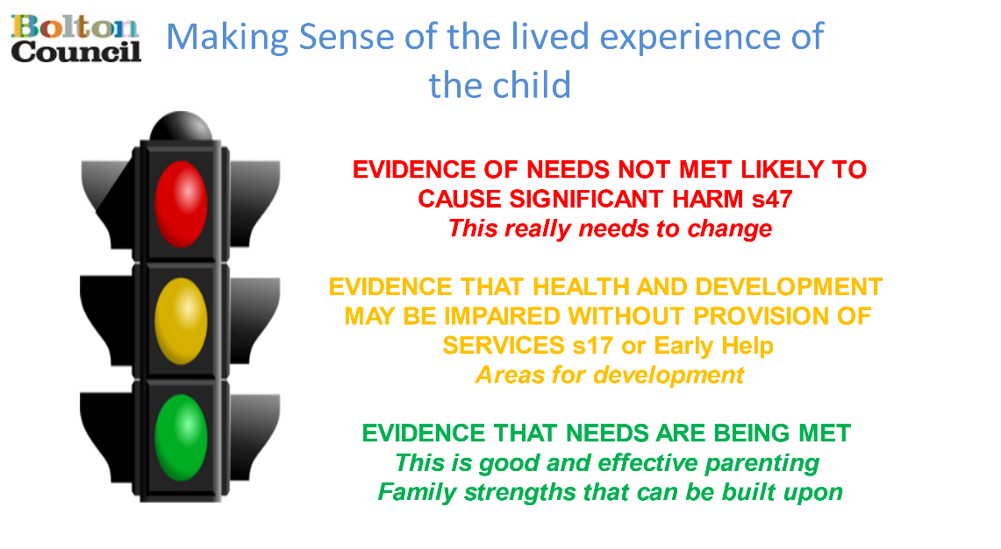

GREEN: Evidence that needs are being met:
AMBER: Evidence that health and development may be impaired without the provision of services:
RED: Evidence of needs not met and likely to cause significant harm:
Impact of risk upon the child/ren/young person. What might happen if nothing changes now or in the future?

