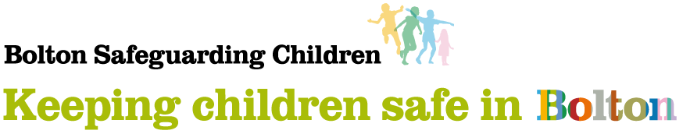

# **S175/S157: Self-Assessment completion guidance**

Bolton advice and guidance to support Education Settings completing the Section 175/157 self-assessment requirements of the Education Act 2002

This guidance has been developed to help support your setting through the completion of your online S175/S157 safeguarding self-assessment. It provides important information about using the online tool to complete your self-assessment as well as guidance about self-assessing your safeguarding provision.

Why is a Section 175/157 required? The requirements of the statutory guidance *Working Together to Safeguard Children (2023)* and *Keeping Children Safe in Education (2023)* place a number of duties on Local Authorities and School Governing Bodies under Section 175 of the Education Act 2002. These include reference to the need to make arrangements to safeguard and promote the welfare of children. The Keeping Children Safe in Education [2024] statement in full reads:

This is statutory guidance from the Department for Education (‘the Department’) issued under Section 175 of the Education Act 2002 (as amended), the Education (Independent School Standards) Regulations 2014, the Non-Maintained Special Schools (England) Regulations 2015 and the Apprenticeships, Skills, Children and Learning Act 2009 (as amended). Schools and colleges in England must have regard to it when carrying out their duties to safeguard and promote the welfare of children.

Section 175 of the Education Act 2002 requires governing bodies of maintained schools and colleges, in relation to their functions relating to the conduct of the school or the institution to make arrangements for ensuring that such functions are exercised with a view to safeguarding and promoting the welfare of children who are either pupils at the school or are receiving education or training at the institution. The Education (Independent School Standards) Regulations 2014 apply a duty to proprietors of independent schools (which in the case of academies and free schools is the academy trust) to ensure that arrangements are made to safeguard and promote the welfare of children. The Non-Maintained Special Schools (England) Regulations 2015 oblige non-maintained special schools to comply with certain requirements as a condition of their approval and whilst approved by the Secretary of State. One condition of approval is that the proprietor must make arrangements for safeguarding and promoting the health, safety and welfare of pupils, which have regard to any guidance including where appropriate, the National Minimum Standards, about safeguarding and promoting the health, safety and welfare of pupils and, in the case of schools already approved, that these arrangements at the school with respect to these matters are in accordance with the approval given by the Secretary of State. The Apprenticeships, Skills, Children and Learning Act 2009 (as amended) requires 16-19 Academies, Special Post-16 institutions and Independent Training Providers to make arrangements to ensure that the proprietor's functions relating to the conduct of the institution are exercised with a view to safeguarding and promoting the welfare of children receiving education or training at the institution. For colleges, non-maintained special schools and independent schools: the definition of ‘children’ applies to the statutory responsibilities for safeguarding and promoting the welfare of children i.e. those under 18.

Note: A link to the full Working Together to Safeguard Children (2023) and Keeping Children Safe in Education (2024) guidance is provided in the Useful References section below.

Bolton Safeguarding Children Partnership has agreed that for the 2024/25 academic year, the S175/S157 process should be undertaken on behalf of Bolton Safeguarding Children Partnership by the Local Authority.

**Online assessment:** To make the process as manageable as possible, the self-assessment process has been developed into a dedicated online survey platform. We fully appreciate that completing the self-assessment is a significant undertaking for schools and colleges and therefore the use of an online platform allows colleagues to input responses, save progress and print/save a copy of the completed self-assessment.

**Timescales:** The completion of the self-assessment will vary between settings and may involve various members of the school team. To provide sufficient time for the collation of required information, the S175/S157 online self-assessment will remain open throughout the Spring Term as highlighted below:

Self-assessment Opens: **Week** **6th January 2025**

Self-assessment Closes: **Friday** **18th April 2025**

**Getting Started:**

Before you start you will need your DFE number, Pupil number on roll and the number of FTE staff employed.

As illustrated in the structure at ***Figure 1*,** the S175/157 self-assessment includes an *Introduction* which requires the completion of setting-specific information. This is followed by Three distinct Parts, namely: *1. The School Approach; 2. Effective Safeguarding; 3. Specific Safeguarding Issues.* Each of these Parts is divided into a number of related Sections which contain the S175/157 self-assessment statements / questions i.e., Parts > Sections > Statements / Questions.

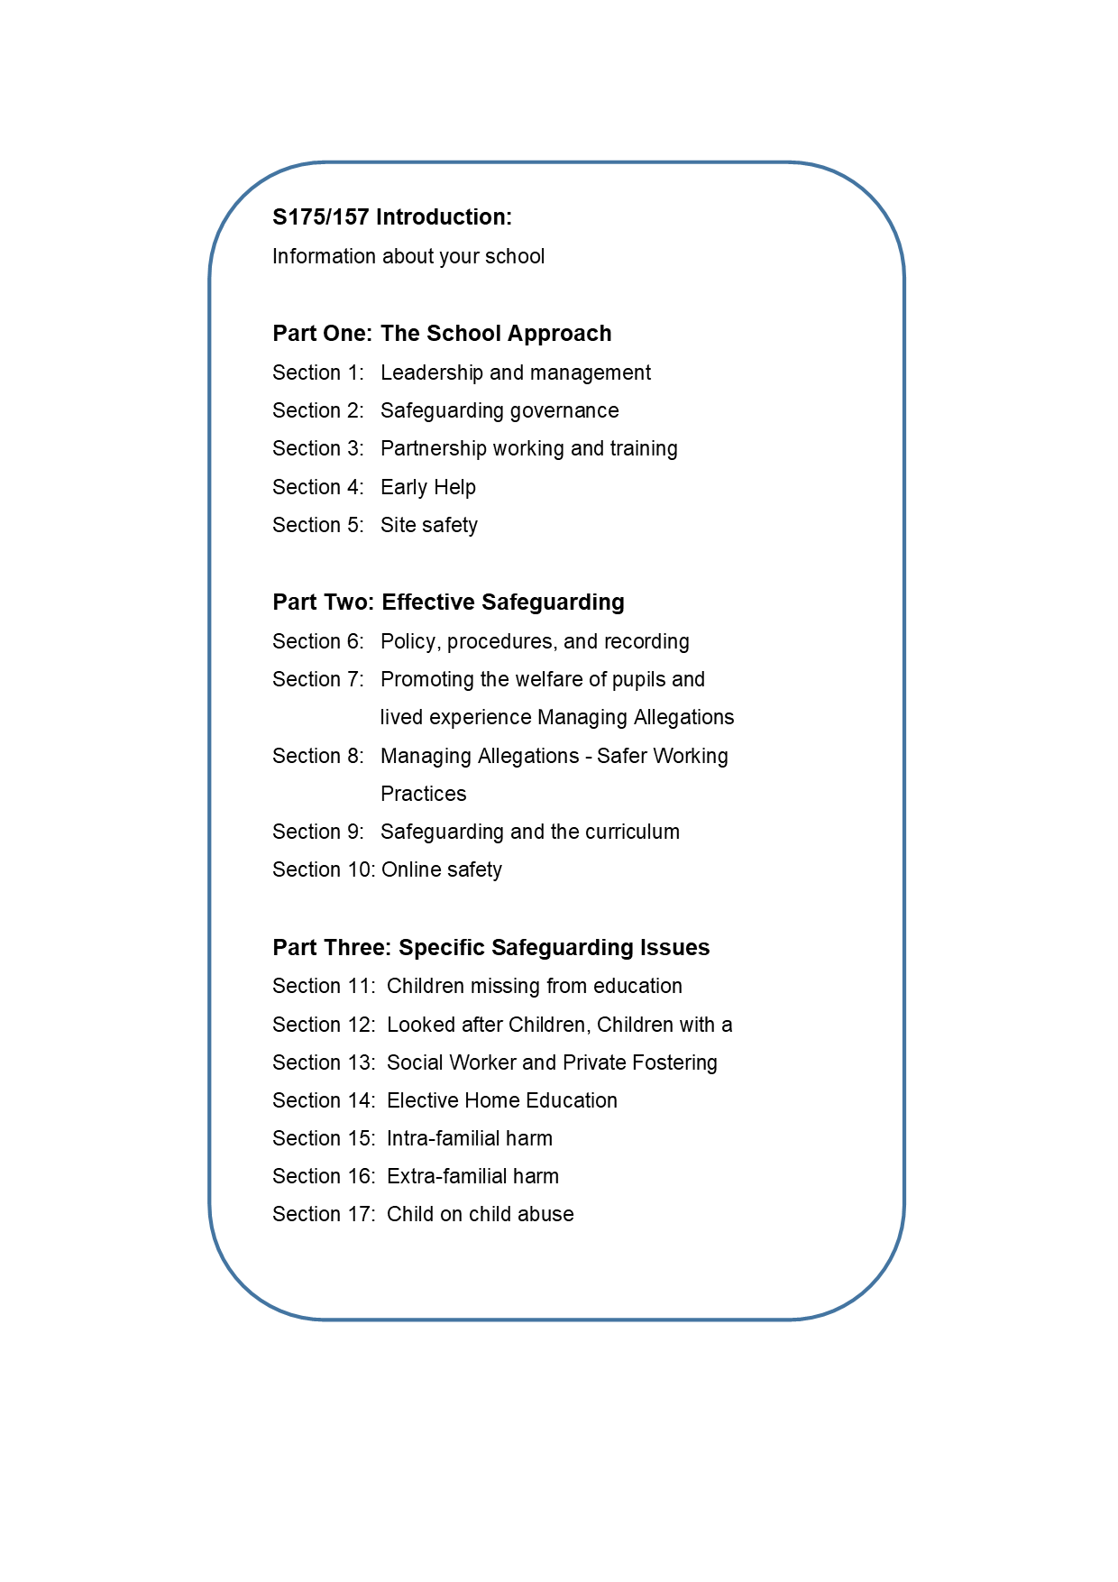 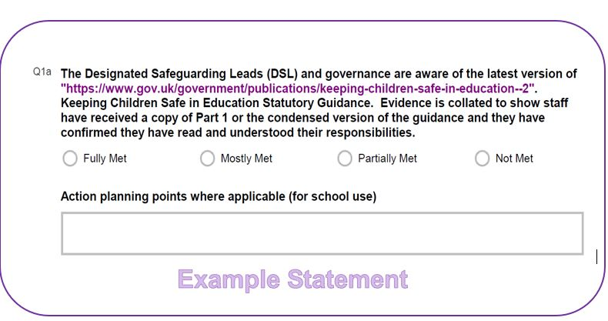

Figure 1: Section 175/157 Overarching Structure

Each Section contains multiple statements / questions ranging between 3 and 13 in number. Unless otherwise indicated, all statements must be completed.

**Part 1: The Approach to Safeguarding**

Section 1: Leadership and management of Safeguarding

Section 2: Safeguarding Governance

Section 3: Partnership working and training

Section 4: Early Help

Section 5: Safety and supervision

**Part 2: Effective safeguarding**

Section 6: Policy, procedures and recording

Section 7: Promoting the welfare of pupils and understanding their lived experience

Section 8: Safer working practices

Section 9: Safeguarding and the curriculum

Section 10: Online safety

**Part 3: Specific Safeguarding Issues**

Section 11: Children absent and severely absent from Education

Section 12: Looked after children, children with a social worker and private fostering

Section 13: Elective home education

Section 14: Intra-familial harm

Section 15: Extra-familial harm/Harm outside the home

Section 16: Child on child harm

Section 17: Extremism and radicalisation

Unfortunately, unless each question has been answered it is not possible to navigate through the assessment. You will find the full list of questions via the Audit Question Bank - [Online Self-assessment Tool (audit) – Bolton Safeguarding Children](https://www.boltonsafeguardingchildren.org.uk/homepage/26/online-self-assessment-tool-survey) which you can read or print prior to completion.

Unless otherwise indicated, the grading system used is based upon a 4-point Likert scale ranging from Fully Met to Not Met.

A N/A option is available on a small number of questions where a question may not be relevant to a setting. This option should only be selected if the question is not relevant.

**Self-assessment grading**: To complete your self-assessment, consider each statement and assign a self-assessed grade that you believe most accurately reflects how your setting’s arrangements comply with the statement at the time of completing the audit.

When assessing your current arrangements against the statements, consider what evidence you have that would support how you have arrived at your assessment. To further assist you, a description of each self-assessed grading level is provided ***Appendix 1*** along with a number of suggested examples.

Useful Tip: You may find it helpful to keep the grading descriptors table available for reference as you work through your self-assessment. A copy of this can be found on the self-assessment grading tile on [Self-assessment Grading – Bolton Safeguarding Children](https://www.boltonsafeguardingchildren.org.uk/homepage/25/self-assessment-grading)

Each individual statement / question also includes a related ‘Action planning points and evidence’section – these sections are provided solely for local school / college use to record any relevant observations, comments evidence or actions you believe may be useful in supporting your development / assessment / action planning.

Note: Information entered in the comments and evidence section is not used in the overarching S175/157 data summary process.

**Saving progress:** The online platform used for the S175/157 allows those completing the self-assessment to save current progress and return to their existing responses later by providing your school e-mail address. Instructions to achieve this are included within the online self-assessment tool and involves a simple process highlighted at ***Appendix 2.***

Useful Tip: Save as you go along. We suggest after each section at minimum. The e-mail link to your saved progress will originate from [***invitation@online1.snapsurveys.com***](mailto:invitation@online1.snapsurveys.com). If you cannot locate the e-mail in your Inbox, make sure to check the ‘Junk Email’ folder.

**Authorisation**: As the self-assessment progresses, it is advisable to confirm the authorisation arrangements in preparation for final submission. These will vary according to setting, but it is essential that whoever is submitting the self-assessment is authorised to do so on behalf of the education setting.

**Submission**: Following the final question of the self-assessment, you can choose to print and save your assessment. Once you have done this you will need to click the ‘Submit’ button.

***Important:* Please note that once the self-assessment has been submitted, it is no longer possible to make changes or to print or save your assessment.**

Should any statements / questions remain incomplete, the online platform will halt the submission and highlight which statements require further attention before allowing progression to the next section.

**Printing / Saving:** On completing your final question of the self-assessment, you will be presented with a final screen Print, Save, Submit. To save a copy of your assessment **Select Ctrl +P**, in the print dialogue box select the printer and option Microsoft Print to PDF see **Appendix 3**. This will allow you to save a digital copy of your responses enabling you to copy-and-paste your submitted responses into your safeguarding action plan, you can then either select the Print option or Ctrl +P to print your copy. We recommend you choose to print in landscape orientation.

**Once you have done this remember to ‘Submit’ your self-assessment.**

By printing your submitted responses, this will provide a reference from which you can develop any resulting safeguarding Action Plan. This can also be used as a useful reference tool for future self-assessments and help to support evidencing local progression.

Useful Tip: An action plan template can be found at [Action Planning from your Self-Audit – Bolton Safeguarding Children](https://www.boltonsafeguardingchildren.org.uk/homepage/27/action-planning-from-your-self-audit)

**Important:** Please note that once you navigate away from this final screen, you will no longer be able to print/save a copy of your completed responses.

**Contact**: The Section 175/157 area on the [Bolton Safeguarding Children](https://www.boltonsafeguardingchildren.org.uk/homepage/22/section-175157-self-audit) Partnership website includes a variety of Frequently Asked Question (FAQs) which address a number of common enquiries. Should you have a question about completing the self-assessment, which is not covered within the FAQs, please contact [SET@Bolton.gov.uk](mailto:SET@Bolton.gov.uk).

**Action Planning:** In completing your self-assessment, you will identify areas that require further development to achieve ‘Fully Met’. As referenced above, each statement includes a *Comments and evidence* section where you may wish to include notes, observations or developments to support you with this.

Useful Tip: The Section 175/157 page provides an example Action Planning template aligned to the self-assessment Sections. [Action Planning from your Self-Audit – Bolton Safeguarding Children](https://www.boltonsafeguardingchildren.org.uk/homepage/27/action-planning-from-your-self-audit).

**Useful references:** Below you will find a series of references referred to in the self-assessment. These references are provided as they appear by section and include both statutory guidance, best-practice advice and resources to support you in developing your safeguarding provision.

**Resources**

Within your self-assessment we have included links to relevant documents.

We have added some additional resources below:

[Keeping children safe in education - GOV.UK](https://www.gov.uk/government/publications/keeping-children-safe-in-education--2)

Working together to safeguard children 2023 - GOV.UK (www.gov.uk)

[Bolton Schools Extranet](https://schoolextranet.bolton.gov.uk/)

[Criminal Exploitation of children and vulnerable adults: County Lines guidance (publishing.service.gov.uk)](https://assets.publishing.service.gov.uk/government/uploads/system/uploads/attachment_data/file/863323/HOCountyLinesGuidance_-_Sept2018.pdf)

[Review of sexual abuse in schools and colleges - GOV.UK (www.gov.uk)](https://www.gov.uk/government/publications/review-of-sexual-abuse-in-schools-and-colleges/review-of-sexual-abuse-in-schools-and-colleges)

[Statutory policies for-maintained-schools](https://www.gov.uk/guidance/governance-in-maintained-schools/statutory-policies-for-maintained-schools)

[Academy trust governance guide - Statutory policies for trusts - Guidance - GOV.UK](https://www.gov.uk/guidance/-governance-in-academy-trusts/statutory-policies-for-trusts)

[Prevent duty guidance: England and Wales (2023) - GOV.UK](https://www.gov.uk/government/publications/prevent-duty-guidance)

[Mandatory reporting of female genital mutilation: procedural information - GOV.UK](https://www.gov.uk/government/publications/mandatory-reporting-of-female-genital-mutilation-procedural-information)

[Sharing nudes and semi-nudes: advice for education settings working with children and young people (updated March 2024) - GOV.UK](https://www.gov.uk/government/publications/sharing-nudes-and-semi-nudes-advice-for-education-settings-working-with-children-and-young-people/sharing-nudes-and-semi-nudes-advice-for-education-settings-working-with-children-and-young-people)

[Homepage - UK Safer Internet Centre](https://saferinternet.org.uk/)

[Working together to improve school attendance - GOV.UK (www.gov.uk)](https://www.gov.uk/government/publications/working-together-to-improve-school-attendance)

[Behaviour in schools - GOV.UK](https://www.gov.uk/government/publications/behaviour-in-schools--2)

[Promoting and supporting mental health and wellbeing in schools and colleges - GOV.UK](https://www.gov.uk/guidance/mental-health-and-wellbeing-support-in-schools-and-colleges)

[Framework-for-action-threshold-document](https://www.boltonsafeguardingchildren.org.uk/downloads/file/36/framework-for-action-threshold-document)

[Bolton Safeguarding Children partnership website](https://www.boltonsafeguardingchildren.org.uk/)

[OS Audit - Online Safety Audit from LGfL | LGFL](https://lgfl.net/TypesOfHarm/OnlineSafetyAudit)

[Template Online Risk Assessment | 360safe](https://360safe.org.uk/overview/template-online-risk-assessment/)

**Appendix 1: Section 175/157 Self-Assessment Grading Descriptors**

|  |  |  |  |
| --- | --- | --- | --- |
| **(1)**  **Not Met** | **(2)**  **Partially Met** | **(3)**  **Mostly Met** | **(4)**  **Fully Met** |
| **Statement compliance:**  Little to nothing currently in place | **Statement compliance:**  Requirements partly achieved but mostly under development | **Statement compliance:**  Requirements mainly achieved but requires some additional development | **Statement compliance:**  Requirements fully achieved, in-place and embedded |
| **Examples:**  There is little knowledge of this area in the school or amongst the staff.  There is no evidence available to support compliance with the statement. | **Examples:**  There is knowledge of this aspect within the school, but it is not fully effective or embedded across relevant staff.  A policy is being developed but is not yet agreed and in place.  There is partial evidence, but it is ad-hoc or is not directly applicable to the statement. | **Examples:**  Knowledge is effective but is recognised as requiring further development or training in some areas.  A policy or protocol has been agreed and is in place but is not yet fully embedded or requires some additional development.  There is good evidence to support the statement requirements. | **Examples:**  The aspect is well embedded within the school or curriculum (where applicable).  An existing policy or protocol has been recently updated to improve its effectiveness or reflect developments and is fully implemented across the school.  There is clear and robust evidence of positive practice to support the statement require |

# **Appendix 2: Response email on saving**

Email from: [invitation@online1.snapsurveys.com](mailto:invitation@online1.snapsurveys.com) – check your junk /spam folder

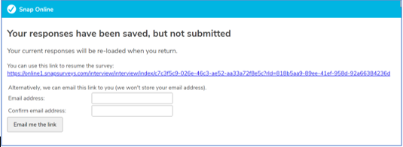`

**Appendix 3: Saving and Printing your Self-Assessment before submitting**

**SAVE Option**

Printer – Microsoft Print to PDF

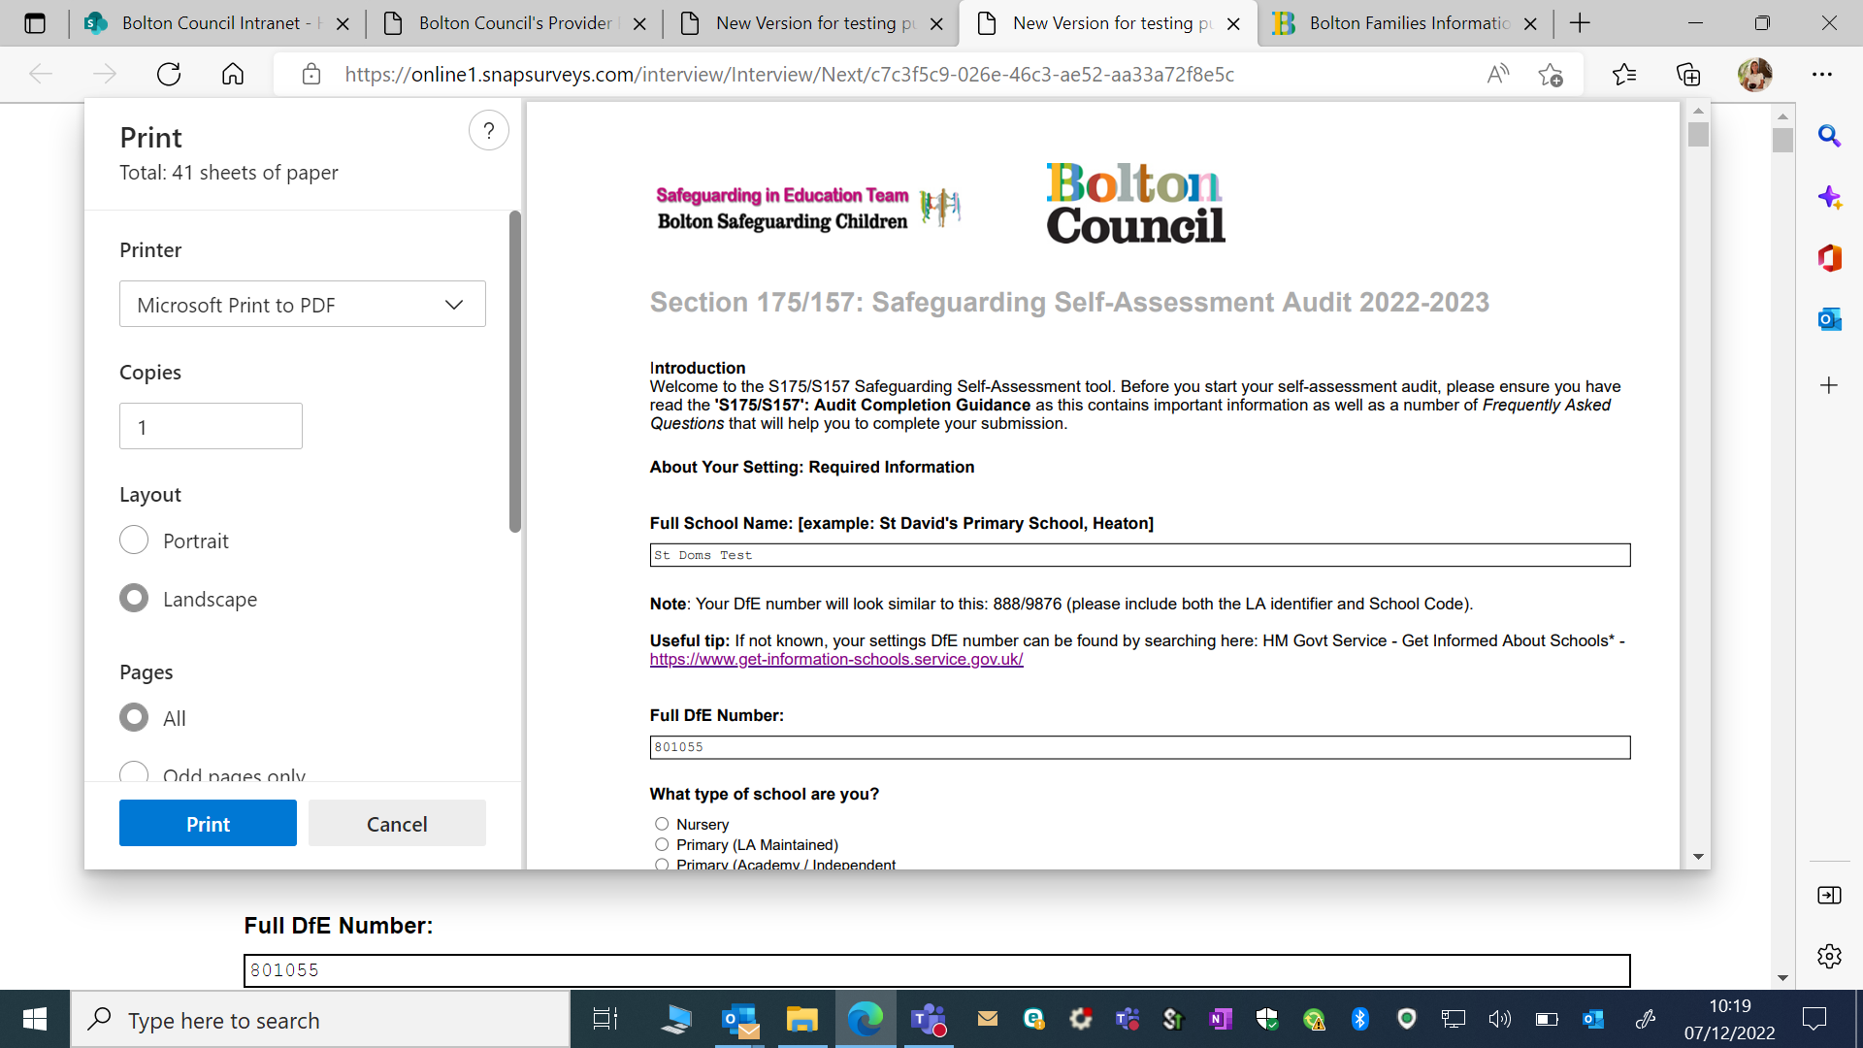

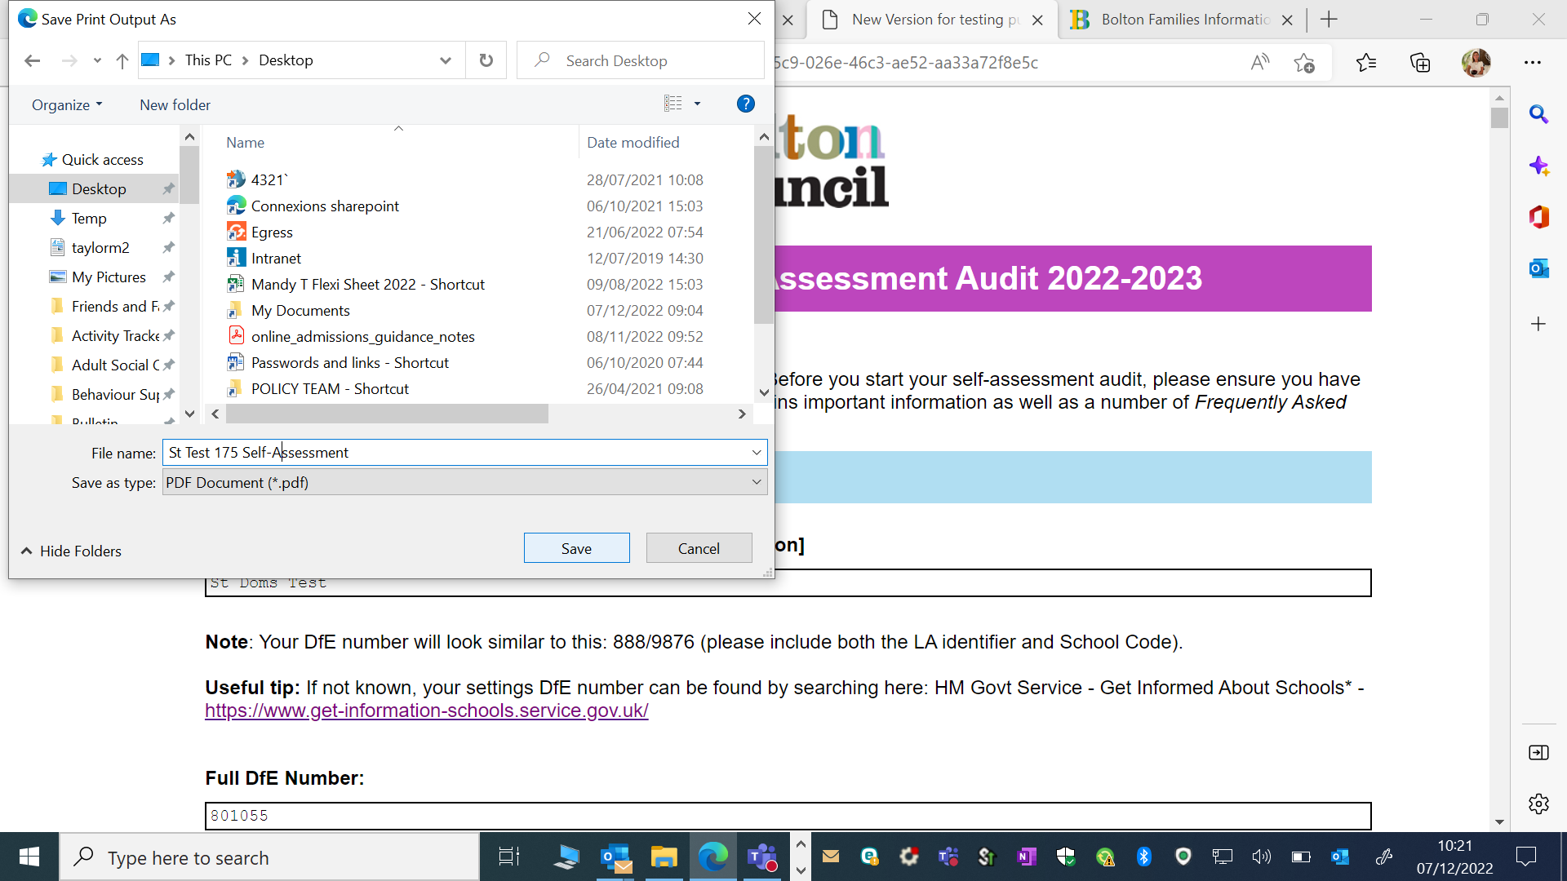

Save your document in your drive

**PRINT Option**

Select your printer from the drop down i.e., colour, mono etc. print

