Name of Professional |  |  | Role
Name of Agency/School
Contact details (Please include email and contact telephone number)
Email |  | Mobile
Name/s of child/ren to be discussed:
Name | DOB
(Press Return to add more lines and Tab to move to next box)
Date | Click or tap to enter a date. | and time of Conference |  | Click or tap to enter a date.
Date report requested |  |  | Click or tap to enter a date.
Date report completed |  |  | Click or tap to enter a date.
Date report shared with parents/carers |  |  | Click or tap to enter a date.
Date report sent to CPU |  |  | Click or tap to enter a date.

What does this young person say about their daily life?
What does this parent/carer say about their daily life?
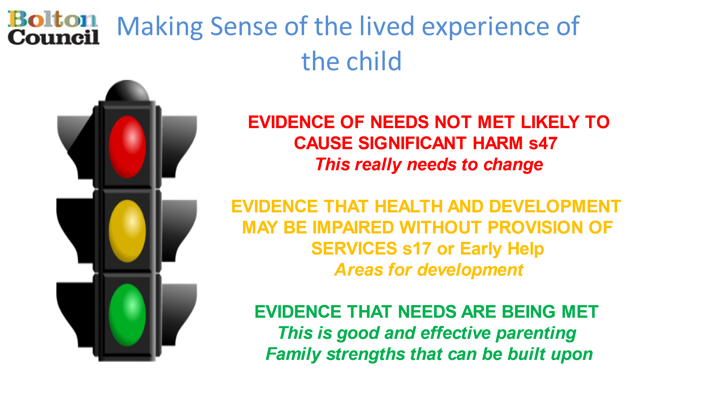
Analysis of Risk: Please refer to the Bolton Family Framework and categorise each point of concern or strength using the Traffic Light System below:

GREEN: Evidence that needs are being met:
AMBER: Evidence that health and development may be impaired without the provision of services:
RED: Evidence of needs not met and likely to cause significant harm:
Impact of risk upon the child/ren/young person. What might happen if nothing changes now or in the future?
In your professional opinion please indicate one of the following recommendations
Child Protection Plan required
Child Protection Plan to continue
Child Protection Plan not required/no longer required

Please record any action’s/recommendations you feel are needed to achieve change:
What are you worried about? | What does good look like? | What action will you provide to help keep this child/ren safe? | By who and by when?
Thank you from
The Independent Reviewing and Conferencing Service
Please return within a maximum of 5 working days of receipt or at least 2 working days of the above meeting date, whichever is sooner and email to cpu@bolton.gov.uk
Please ensure you share your report with parents/carers prior to conference.

